Are you a victim of microaggression?
Date: March 16, 2012 - 4:54PM

Candice Chung

Ja'mie King: "Wife beaters and rapists are nearly all public school educated. Sorry, no offence."
Maybe it’s the dim lighting, or maybe it’s the soft 80s rock – but there’s something about catching a taxi alone at night that gives cab drivers the illusion they’re on a speed date with you. At least that’s one way of explaining the huge number of uncomfortably intimate conversations I’ve had with taxi drivers over the years.
There are the standard ice-breakers – whether I’m single, what I do, where I’d been, and it usually ticks along politely until I get one question wrong.
Driver: “So, where are you from?”
Me: “Oh, I grew up here.”
Driver: “But I mean, where are you from,originally? What are you Thai? Malaysian?”
And that, I’ve come to recognise, is my cue to provide a solid explanation for being Asian. Of course, I could’ve mentioned I was born in Hong Kong from the start, but what if they decide to compliment me on my English? It’d be rude to take credit for what’s practically the only thing I speak.
Interestingly, the question of ancestry hardly ever comes up in casual banters for my Anglo Saxon friends (although they too are descended from immigrants). We may laugh at the overwhelming percentage of Republican voters who still believe Barack Obama is Muslim, but even in a truly multicultural society like ours, are certain cultural and religious backgrounds perceived as more ‘authentically Australian’ than others?
The term ‘microagression’ was first coined by psychiatrist Chester M. Pierce in 1970 to describe the everyday things we say or do which causes someone to feel ‘othered’. Originally a racially-related phenomenon, its definition has since evolved to include any subtle verbal or non-verbal communication that conveys insensitivity towards a person’s sex, social status, physical appearance or sexuality.
Microaggressive remarks can often come in the form of back-handed compliments. For example, “She’s gorgeous for a big girl” or “I would never be able to tell you’re GAY!” Essentially, they are messages that appear innocent enough on the surface but contain ‘demeaning meta-communications’ to its recipients.
According to Columbia University psychologist Derald Wing Sue, “Most people... harbour unconscious biases and prejudices that leak out in many interpersonal situations.” Just think of all the talk-back radio rants that begin with “Now, I’m not racist/ sexist/ homophobic, but ...” or any number of ‘well-meaning’ comments that finish with: [chuckle] “No offence”. And since most ‘microaggressors’ are genuinely unaware of any wrongdoings, this makes it nearly impossible to confront the situation without evoking paranoia.
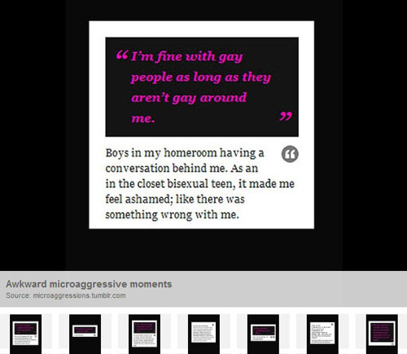
Ironically, Sue’s research also found that most of us are actually better at handling overt acts of discrimination than subtle insults, because at least the former has “no guesswork involved” whereas victims of microaggression are “often left to question what actually happened”.
The challenge ultimately lies in making the invisible visible – however ‘insignificant’ it may be. And we can do this, writes Cultural Anthropologist Zara Zimbardo, by “returning the gaze”: “In feminist discourse, it’s when “the targeted ‘other’ look[s] back at the non-target “norm”, putting them in the spotlight of scrutiny.” Viral videos like S**t White Girls Say to Black Girls or the Microaggression Project – where contributors are encouraged to submit snippets of microaggressive insults – are great examples of putting the spotlight on the myriad ‘invisible things’ that make up a marginalised experience.
In the end, this is an awkward subject because it often requires well-meaning people to reflect on their own bias and privilege. Sure, you may object to racism, but do you speak really, reaaally slowly when you order Thai home delivery? Perhaps no one sums up the value of self-awareness better than David Foster Wallace in his famous ‘This is water' speech:
“Two young fish swimming along and they happen to meet an older fish swimming the other way, who nods at them and says "Morning, boys. How's the water?" And the two young fish swim on for a bit, and then eventually one of them looks over at the other and goes "What the hell is water?"”
It’s surprising what goes unnoticed sometimes.

