Contents removed from racist Facebook page
Date: August 8, 2012

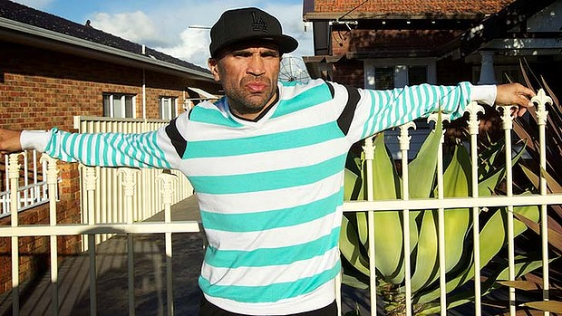
"It just goes to show how behind we really are" ... Anthony Mundine. Photo: Wolter Peeters
The creators of a racist Aboriginal Memes Facebook page - described as a potential breach of Australia’s Racial Discrimination Act - have removed all of the controversial images.
All of the page’s content was removed earlier today after repeated complaints to Facebook and after confirmation that the Australian Communications and Media Authority was investigating.
So as long as you have a pretense of being funny about it you can vilify Aboriginal people? Really?
Facebook has not deleted the page; it still exists with a classification of ‘‘controversial humour’’.
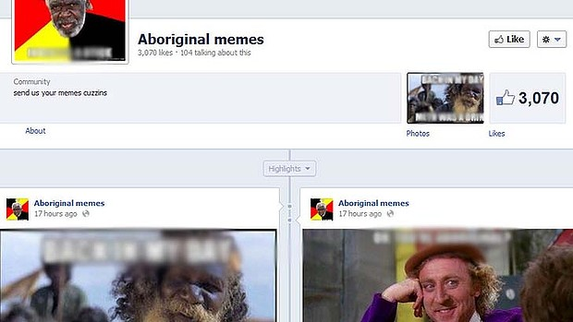
The Aboriginal Memes page is not hate speech, according to Facebook.
Race Discrimination Commissioner Helen Szoke said the page, which targeted Aborigines, could be a breach of the Act and earlier called on the social network's operator to take the page down.
Advertisement
Communications Minister Stephen Conroy said today the page was "offensive", "not appropriate" and "denigrates our indigenous community extensively" but stopped short of demanding that Facebook take it down, saying "I think it should be taken down".
"Pretending its humour doesn't really change [things]," Conroy said.
The Coalition on the other hand has vowed to repeal racial vilification laws.
ACMA is also investigating the page following a campaign condemning Facebook over its claims that the page is not considered hate speech. The racist "Aboriginal memes" page portrayed Aboriginal people as inferior drunks who sniff petrol and bludge off welfare.
"My view is that the material is offensive and it goes over the line of humour and even controversial humour because what it's doing is depicting a whole race of people in a way that's negative, that's ridiculing them, that's mocking them and is offensive," Szoke said in a phone interview.
Boxer Anthony Mundine said it was "appalling" that Facebook had refused to remove the page.
It appears that Facebook tolerates hate-mongering but refuses to allow mothers to post images of themselves breastfeeding their babies.
Facebook's community standards page forbids "hate speech" but Facebook has responded to those who complained about the Aboriginal Memes page, saying it was "not able to confirm that the specific page you reported violates Facebook's statement of rights and responsibilities".
The page, which has 4183 "likes", was briefly taken offline last night before reappearing with the words "Controversial Humor (sic)" next to the page's title. It consisted of various images - usually of an indigenous person - each with racist text over the top of it.
Facebook says on its website that content which attacks people based on their perceived race, ethnicity, national origin, religion, sex, gender, sexual orientation, disability or disease "is not allowed".
"We do, however, allow clear attempts at humor or satire that might otherwise be considered a possible threat or attack," the website states. "This includes content that many people may find to be in bad taste."
Chris Graham of the NSW Aboriginal Land Council's Tracker magazine said that while Facebook may have a policy on what is and isn't hate speech, "the fact is that Facebook page is illegal". "It is a clear breach of the Racial Discrimination Act. Is Facebook genuinely suggesting it is above the law?"
Approached for comment this morning, a Facebook spokesman in Australia said: "At this point in time, we've not got anything we can give you on this."
Szoke said while she had yet to receive a formal complaint - required before an investigation takes place - she believes "this could constitute discrimination under the Race Discrimination Act".
She urged Facebook to remove the page and said now was a good opportunity for the site to revisit its guidelines and "test whether they are in tune with community opinion".
"If someone chose to lodge a complaint at the commission then what we would do is attempt to conciliate that complaint and get an appropriate outcome," she said.
"That may be to remove the material, review guidelines about what the threshold is on racism and how racism is depicted on the Facebook site, to putting a public apology about the harm that's been created."
This conciliation process may not be possible under a future Coalition government as Tony Abbott has said he would repeal laws prohibiting statements that offend people on racial or ethnic grounds. At a press conference today Senator Conroy took a different view, saying "we don't want to live by those [Facebook's] standards".
ACMA has referred the content to the Classification Board. But it is understood that it is unlikely that the content would fall under "prohibited content" as defined by the Act, which prevents content such as child and terrorism material.
"So as long as you have a pretence of being funny about it you can vilify Aboriginal people? Really? If that's their [Facebook's] policy they need to have a serious re-look at it," Graham said.
"Racist doesn't even begin to describe the images. They're so offensive it beggars belief."
Graham said that while Facebook could take the page down today, tomorrow it would be back up somewhere else. But that didn't excuse Facebook from its responsibility not to spread "this sort of hateful, disgusting material".
"There's a certain amount of futility in all this. It's never going to stop because the people creating it know there's a big market for it in Australia. And that's the problem," he said.
"What this does is celebrate the destruction of a people. It celebrates the fact that Aboriginal people feel so hurt and so disempowered that they petrol sniff to forget their problems ... I don't think Mark Zuckerberg had this in mind when he invented what is otherwise a fantastic social networking platform."
Mundine said: "It just goes to show how behind we are, how racist this country is. A lot of people that ain't as strong as me it plays with their emotions ... but shit like that just motivates me really to do the best ever and that's what I'm going to do, I'm going to be the best ever and they'll have to say a black man was the best ever full stop period."
Andrew P Street has been part of a Facebook campaign to get the racist page removed from the site.
"I got sent the link by a friend ... dutifully shared and reported it, and that would have been that if FB's bot response had been 'a human will look at this shortly and report back'," he said.
"But because their response implied that nothing was going to be done, I got strident - and then when the page went down and then reappeared, with the new URL and descriptor suggesting 'this WAS racist, but now we've told you it's totally hilarious it's all OK!', I got f---ing livid."
Ben Gertz, a national Aboriginal and Torres Strait Islander officer with the National Union of Students, said the page was unquestionably racist and portrayed indigenous people as "a bunch of inferior petrol sniffers".
"I think social media gives people an outlet to promote their racist and discriminatory views because on social media a lot of profiles can be very faceless so it gives people that option to cower behind a faceless screen," he said.
Tiphereth Gloria, social media planner at VML, said the page was racism hiding under "humour". Since it uses visual meme generators, contributors are able to stay anonymous.
"Facebook likes to stay out of these controversies. The last time they took photos down it was women's personal photos of themselves breastfeeding their children," she said. "They eventually reinstated these. How racism is allowed to stay up versus breastfeeding is anyone's guess."
James Griffin of social media monitoring firm SR7 said anonymity on the web was a double-edged sword - it allows people to speak out in support of good without condemnation but it also allows people to say terrible things without consequence.
"Two contrasting examples for retaining anonymity [on Facebook pages] would be disgusting pages like this, where it makes sense to remove it, however alternatively, social media played such a large role in facilitating the Arab Spring and helping shed light on the plight of people in dire situations," he said. "In that respect anonymity is vital."
In a position paper on a national anti-racism partnership and strategy, released in June, the National Congress of Australia's First Peoples identified cyber-racism as one of its four major priorities.
"Congress has identified increasing concern around the prevalence of racist commentary and imagery on the internet and in social media, and recognises the destructive potential this material can have in spreading falsehoods, reinforcing racist stereotypes and undermining social cohesion," it wrote.
"Congress believes it is particularly important to identify effective strategies to combat the existence and expansion of cyber-racism. Congress notes that social media is an important tool for effective contemporary campaigns."

