Differences are just a slip of the mother tongue
Date: February 17, 2013

Ian Rose
There's no worries about celebrating Australian English.
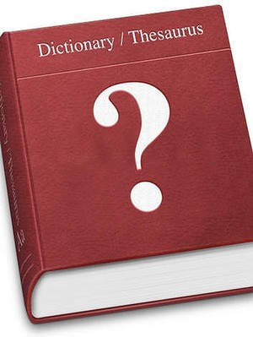
'Language doesn't stand still, not even the fusty old English language.'
THIS Thursday, in case you were wondering, is the day the United Nations has designated ''International Mother Language Day''. I'm guessing they decided against ''Mother Tongue'' due to the possibility of lurid Oedipal associations. The honourable aim of this particular 24-hour awareness-a-thon is ''to promote the preservation and protection of all languages used by peoples of the world'', which clearly has nothing to do with having sex with your mother.
I have a confession to make. I am English. There. That's better out than in. I have been here in Australia for more than five years, have somehow found myself raising Australian children and would appear to be here to stay, but cut me and I bleed the stuff that the donor banks still reject out of lingering ''mad cow'' aversion.
As far back as 1820, just 32 years after the colonial foundation at New South Wales, Australian English was recognised as a variant of proper, I mean British, English. It seems that first-generation settlers, exposed as they were to a range of regional accents and languages (Irish Gaelic being widely spoken), and the drive for peer solidarity, created a brand-new patois, which became the foundation of a brand-new dialect.
There are relatively few differences between Australian and British English these days, but that doesn't mean I haven't accumulated a handsome collection of semantic quibbles. The verbal tic of prefacing every statement with a ''Look …'' , for instance, so prevalent among Australian pontificators in fields ranging from federal politics to drug-infested national sports, sounds rather belligerent to the genteel British ear. This type of divergence between our tongues (again, forgive the erotic imagery) can emphasise perceived differences between national characters. So while the famous British reserve leads to convoluted avoidance of direct statement, Aussie candour, calling a spade a flamin' spade, fits right in with a firm, crap-cutting ''Look …''
Likewise, breezy conversation closers such as ''no dramas'', ''too easy'' or (my personal favourite) ''good on ya'' convey the kind of casual optimism that is the secret envy of my morose compatriots. We Brits, at least those of my generation, born and bred on a soggy little island, raised on fish-fingers, mushy peas and Margaret Thatcher, can find a positive outlook something of a stretch.
There is an almost athletic vigour to many Australian expressions, which again concurs with the outdoorsy, boisterous national stereotype. You lot don't just arrive, turn up or get there. No, you insist on ''rocking up''. I don't believe I've ever rocked up anywhere, and I doubt I ever will, no matter how long I remain here. It sounds so energetic. It's telling that the sedate British greeting of ''How are you?'' is rendered more dynamic, with its emphasis on motion, by the Aussie variant, ''How ya goin'?''
There's one word, used more widely here than in Britain, that strikes an odd chord for me. The first time I heard a violent physical assault described as a ''bashing'' on a news bulletin, I almost choked on my (Marmite on) toast. Getting ''bashed'' always sounds a bit cartoonish to me.
Naturally, my own speech these days betrays the time I have spent in Australia. I no longer correct myself on the occasions I mistake flip-flops for thongs or a beer bottle for a stubby. I love saying ''No worries'' and I'm even beginning to mean it when I do. My language is changing, and so is everyone else's.
Language doesn't stand still, not even the fusty old English language. Right now it seems in the throes of some kind of seismic shift, getting freaky with hash tags and acronyms. It seems likely that a hundred years from now, whatever's being spoken and ''written'' around these parts won't look a hell of a lot like what we have now. Which is why it's also worth reflecting, on International Mother Language Day, that Australia is the custodian of the oldest known languages on earth. And that most of them are endangered.

