Swearing with style
Date: February 2, 2013

Profanity just isn't the curse it used to be, writes Samantha Selinger-Morris.
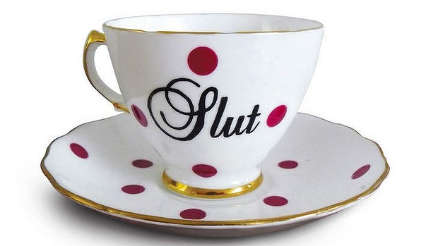
Obscene delights … it may not be everyone’s cup of tea, but cuss words now adorn a wide variety of “genteel” products. Photo: courtesty of trixiedelicious.com
The belief that swearing is bad goes as far back as there have been neighbours to bug people into doing it in the first place. In 350BC, Aristotle warned that "the light utterance of shameful words leads soon to shameful actions". More than 2000 years later, Oscar Wilde looked down his nose before declaring: "The expletive is the refuge of the semi-literate."
But now, smarty-pants creative types and thoughtful parents are giving those long-held truisms the middle-finger salute. Swearing, they say - specifically when the curse words are plastered on elegant items like letterpress-printed greeting cards, throw cushions and gold necklaces - is the perfect way to express deep personal truths they would otherwise be too uncomfortable to voice.
For instance, how to spread love for your fellow man on Jesus's birthday, while also expressing your distaste for how commercial Christmas has become?
When Perth mother of three Donelle Toussaint found herself with this conundrum this past holiday season, she turned to Calligraphuck, a Melbourne-based company that makes cards with phrases like "Merry F...ing Christmas" and "You Magnificent Bastard" stamped on them in florid blue calligraphy.
"I usually don't send Christmas cards at all," says Toussaint, 41. "I don't bother because you buy these whatever Christmas cards and they're quite empty sentiments, and I don't have the time to fill them with something better, deeper.
"I said, 'Ah!' when I first saw them. It was like, 'Wow, why has someone not done this earlier?"
Alistair Farland, a 22-year-old University of Sydney business student, felt the same way when he was stymied by a common problem a few months ago. How could he show affection for his mates without feeling too cheesy?
"How many guys in their early 20s will send a 'Joy, blessings and peace upon you and your family' card to other guys in their 20s?" he says. "No!" He sent out Calligraphuck's "F... You" cards instead.
A heap of other new, profanity-laden luxury gifts could have helped them spread their love just as well. Like the recycled felt pillow with the word "Merde" (French for "shit") stitched on it, by American designer Alexandra Ferguson. Or the $1850 gold filigree ring that spells out the phrase "F... Off'' in twisted gold by British jeweller Solange Azagury-Partridge. Or the "F... It" gold bracelet sold by Screwords, an online jewellery business on Etsy.com established for the sole purpose of elevating "pretty dirty words".
So why are so many of us willing to risk letting our nearest and dearest think we'd like them to take a leap, when in actual fact we'd just like to give them a hug? It could be because the swear word, once the rat-bag delinquent of our lexicon, is coming up in the world.
The last six months alone have seen the release of two academic tomes, both from the University of California: Assholes: A Theory, by philosophy professor Aaron James, and Ascent of the A-Word: Assholism, the First Sixty Years, by linguistics professor Geoffrey Nunberg. Both legitimise what fights with our families have long taught us: that a well-chosen profanity often cuts to the heart of an issue quicker and better than a bunch of highfalutin' words.
Even The New York Times, well-known for its refusal to print swear words, has come on board. The paper recently gave a rave review to The Cursing Mommy's Book of Days, published in November by author Ian Frazier. The novel explores - through the frustrations of a housewife with a Tourettic habit of swearing - the psychic pain caused by life's little problems, like not being able to find the edge on a roll of tape, or being tripped up by a cake recipe. Some sample dialogue: "WHAT A F...ING MESS!! I'M ON MY BACK ON THE KITCHEN FLOOR IN A PUDDLE OF F...ING CHOCOLATE GORP!!"
As New York Times reviewer Judith Newman put it, the book reveals a central irony of modern living: that we cope pretty well with big challenges, like climate change, but go crazy over the little things we can't control. "She can't help but tell the truth," wrote Newman of The Cursing Mommy. "And her truths are our truths."
If only she had one of the throw cushions embellished with embroidered curse words that Dame Judi Dench frequently makes for her co-stars. The one that reads "F... 'Em, F... 'Em, F... 'Em", for instance, has provided enormous succour to its recipient, Sir David Hare, the British playwright who wrote the screenplays for The Hours and The Reader.
"It was directed at the world in general and at anyone who brings you down - Judi as much as me," Hare tells me about the cushion, which sits on a sofa in the studio where he works.
"It may be producers, it may be politicians, it may be traffic wardens, it may be journalists. And yes, the cushion does hearten me, because I think it's wonderful that a great actor put so much effort and endeavour into cheering us both up. She succeeded."
Could this trend be a backlash against the constant derision of so-called "first-world" problems? A material manifestation of a growing collective desire to scream, "We know we shouldn't complain about leaking roofs and speeding tickets when people are starving, but who the hell made you God of my feelings?!"
Keith Allan, Monash University emeritus professor of linguistics and co-author of Forbidden Words: Taboo and the Censoring of Language, muses that the new luxe swearing is largely the preserve of the young.
"I'm much more likely to say it than to write it," says Allen, 69, of swear words. "I think it's a hangover from what's good breeding, what's drummed into you as a kid." He adds, in a near-whisper, about the Calligraphuck cards: "My wife wouldn't let me buy one."
He's not the only one who won't be picking one up. "I guess it just comes down to personal taste," says IT journalist Angus Kidman, who once wrote a university thesis on the semantics of swearing in Australia. "I don't like stuff with calligraphy on it."

