Today's special? The literary flourish
Date: January 22, 2013

Larissa Dubecki

Decadent desserts, funky chips - too many menus are a brain-addling assault on the English language.
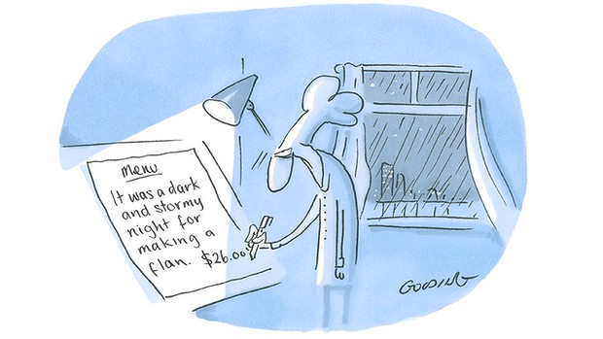

Illustration: Matt Golding.

MEMO TO overzealous chefs: a dessert cannot be wicked. Even given the most generous jurisprudential parameters it is a stretch to allege a combination of sugar, flour and vanilla essence can embody evil. By the same token, a dessert cannot be decadent. Perhaps it depends on the circles in which you move, but the ordering of a brownie generally does not indicate moral decline. It is simply a brownie.
Therein lies the rub. Food writers presumably love language as much as they love food - or at least enough to do weekly battle against the quagmire of ostensibly food-applicable yet unseemly words such as moist and succulent, not to mention the self-evident wrongness of ''wafting aromas''. Yet menus have defied the invention of copywriters and spellcheck to remain one of the great bastions of crime against English. It's no accident the title of Lynne Truss' polemic Eats, Shoots and Leaves is a joke relating to diet - the panda's, specifically - but the ''beetroot, ricotta ravioli'' I recently ordered would certainly have made more sense without the comma.
The misplaced comma, apostrophe and Random Capitalisation are merely the shallow end of my thesis. Deftly sidestepping shadows of Russell Crowe in A Beautiful Mind, reading menus for a living reveals a hidden code. A menu will quickly tell you what a restaurant is about, where it's aiming, if you're likely to enjoy it and, without having to look at the dollar signs, how much it's going to cost you.
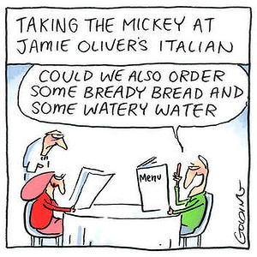

Illustration: Matt Golding.

Perhaps it's the brain-addling effects of reading a dozen enigmatically edited restaurant screeds each week, but they conform quite nicely to literary trends. From the descriptively ebullient high Victorian to the rudely truncated telegraphic form, recent encounters include the haiku, the romantics, the dirty realists (the dude food movement, naturally) and the Fifty Shades of Grey set, who oversell dishes like culinary Viagra.

Thomas Keller? Dishes such as his classic oysters and pearls would put him with the poet set, although the overuse of inverted commas indicates he's also a postmodern wildcard (''caponata'' translates as ''nothing like a caponata you've ever seen, you pleb''). Gordon Ramsay's unfashionably information-heavy listings (''pressed foie gras, smoked and confit duck with peaches, walnuts and pickled girolles'') indicate a personality on friendlier terms with tradition than his TV persona would let on. Chez Panisse - ''hand-cut pasta with Monterey Bay squid stewed in its ink'' - confirms Alice Waters as the consummate food nerd name-dropper. As for Jamie Oliver, the spiritual leader of the conversational idiomatic crew, little needs to be said beyond noting the following examples from the menu at Jamie's Italian in Sydney: ''our famous polenta chips'', ''posh chips'', ''lamb chop lollipops'' and ''crispy squid''.
Not to second guess the conversation between the jubbly one and his audience, which is dominated by people with a glancing interest in food from the telly and for whom eating out is a treat rather than the norm, this brand of diner will presumably be delighted by the exuberance of Oliver's ''funky chips'' and will appreciate being told his panna cotta is ''creamy'', his chilli and mint salad is ''zingy'', and his rocket pesto ''peppery''.
His enduring love for the lowly adjective is a clear mark of separation from the local highbrow crew, which has cultivated a menu aesthetic that left boring old minimalism in its wake to arrive at deliberately enigmatic.
Call it telegraphic modernism, if you will, where everything but nouns is banished and punctuation is minimal, often in tandem with the abolition of upper case.
What purpose does it serve? Beats me, although maybe it's thought respect for the chef's artistry will spike when diners are faced with a list of ingredients with no indication of what precisely is going to happen to the ''hapuka, corn, sea urchin'' or the ''pigeon, artichoke, mushroom, hay''. This leads to being held hostage to waiters who intone monologues about the inspiration, ingredients and technique behind the ''fish. chips''.
This is why it's so handy that many waiters are unemployed actors.

Menu crimes: my eight favourite ingredients
Chocolate
Menu-ese would have it that chocolate caused the decline and fall of the Roman empire. The hand-wringing guilt suggested by words such as ''decadent'' and ''indulgent'' is grossly conspiratorial; as for the genius who invented ''death by chocolate'' - well, no, unfortunately you can't. I've tried.
The preamble about organic-seasonal-local
No longer worth boasting about, it's a new minimum standard - and it doesn't take a cynic to suspect half of it's greenwashing anyway. As for the ''respecting the whole beast'' spiel, it's nice to know the animal about to be eaten gave permission for its trip to the slaughterhouse. Really, it is.
Name-dropping
That's not a cheese-and-ham toastie, it's Andrew's Choice ham with Maffra cheddar and Tatura butter on Zeally Bay sourdough. Got it?
Gourmet
A redundancy that's come to mean the opposite of what it promises. It's time to pack it away when mass-produced potato crisps come in ''gourmet'' flavours of sea salt and balsamic vinegar. See also: organic, artisan.
Kitchen tautologies and technical guff
Oven roasted. Hand-cut anything. On the other hand, pan-fried is a term worth defending, in so far as it differentiates from deep-fried.
Famous
For example, ''Our famous fish pie''. If you have to say it, it isn't.
Emotives
Given the temperament of many chefs, the gnocchi are hardly likely to have been made ''lovingly''; chances are they were made angrily, furiously or homicidally. Declaring your own food ''delicious'' is just begging to be shot down.
The just plain wrong
From recent menus of Melbourne: seasonal medley of vegetables. Chef's journey. ''Lashings of'' anything. Pounded rabbit. Ballistic baked cheesecake.

