Tweet your way to your next job

Date: February 18, 2013

Forget paper resumes, your next job could hang on a 140-letter tweet.
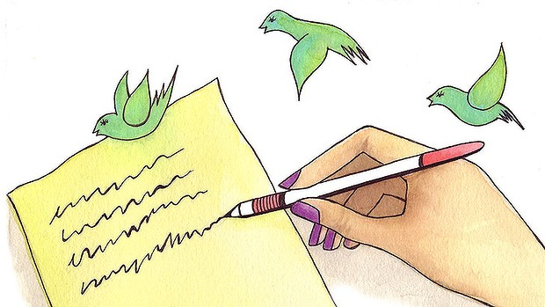
Could a well-worded tweet replace the need for a written resume in some workplaces? Some US employers are already hiring candidates based on their Twitter form.
Several tech-forward US marketing companies are going where few have gone before: they're ditching the resume and the conventional job interview process for tweets. A simple tweet or two - sometimes called Twitterviews - can lead to a job. In a nation where unemployment stands at 7.9 per cent, how you tweet can now determine how employable you are.
"The paper resume is dead," says Vala Afshar, chief marketing officer at the tech firm Enterasys Networks that is in the process of hiring a six-figure, senior social media strategist based on tweets. Afshar refuses to even look at resumes. "The web is your resume. Social networks are your mass references."
The paper resume is dead. The web is your resume. Social networks are your mass references.
Beginning this week, job prospects can begin tweeting for the job, which he hopes to fill by April. "I believe the very best talent isn't even looking for work," Afshar says. "They're mobile and socially connected and too busy changing the world."
Think of it as a 140-character job interview. Even the folks at Twitter are a bit surprised. "I don't think we've heard of that before, actually," says spokeswoman Alexandra Valasek in an e-mail.
But 22-year-old Kristy Webster totally gets it. She created and is coordinating an offbeat bid by her employer, The Marketing Arm, a division of ad giant Omnicom Group, to hire five summer interns based on how they respond to five tweets over five days. Those who respond with the best tweets will become job finalists. No one will ask them for resumes.
"We're meeting our potential talent where they live," says Webster, whose intern tweet-off will begin early next month. "What's more relevant than Twitter to our interns?"
Hiring via tweets worked just fine for Aaron Biebert, a commercial director from Milwaukee. About one and a half years ago, he hired a social media coordinator based on 40 public tweets - with no in-person interview at all.
"It didn't matter to me what they're like in an interview setting," Biebert says. "All that mattered was their online personality." Although the employee recently left for a higher-paying job elsewhere, Biebert says, this is how he plans to conduct future hiring.
Tweets could quickly become the hiring model for companies seeking tech-savvy or marketing employees, says career coach Jan Melnik. "It's perfect for any company that want to take advantage of what Millennials bring to the marketplace."
Still, she adds, there are some jobs where tweets will never replace resumes and eye-to-eye interviews. "You won't see a CEO - or a college professor - hired based on a tweet," she says. Nor would she hire someone based solely on a tweet. But, she laughs, "I would hire someone on Skype."
Meanwhile, a darker side to social media is emerging with workers reportedly engaging in cyberbullying in the workplace.
Some are routinely use content from Facebook, Twitter, YouTube and other social-media services to intimidate and harass subordinates and rivals at work.
"Adults are now finding themselves in uncharted territory when it comes to social media," says Jenny Ungless, a life coach and workplace consultant.
In a recent global survey of 4000 adults, 82 percent of respondents agreed that posting or messaging defamatory remarks about a colleague amounts to cyberbullying. And 9 percent disclosed incidents in which information gleaned from a social-media service was used to their detriment by a manager.
Companies are just beginning to consider policies to effectively govern social-media etiquette among employees, says Tony Anscombe, senior security analyst at AVG.
One in 10 respondents to AVG's survey discovered secret discussions about them online were initiated by colleagues using social media, and 11 percent reported embarrassing photos or videos uploaded onto social-media sites.
Awareness about the potential invasiveness that can stem from use of social media has not kept pace with its pervasive use.
"Until everyone is clear about exactly what is and isn't acceptable online behavior, trying to enforce policies will just fail, leaving the door open to cyberbullying and invasion of privacy," Anscombe says. "If organizations take the time to first educate before establishing and enforcing policies, privacy can be protected in the workplace without having to sacrifice any of the social activity we all enjoy."

